0

['2003-08-01']

['2007-08-02']

251

-0.09947643979057585

-0.0068494578815679885

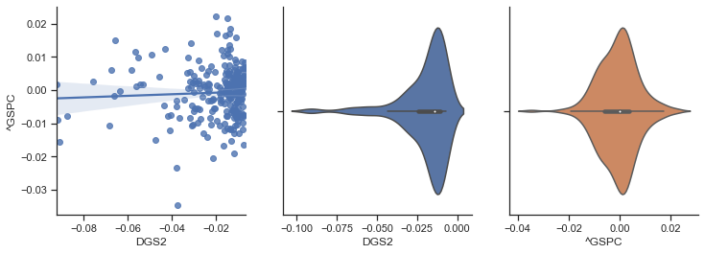

-0.18674375004978072

264

-0.0068494578815679885

0.0

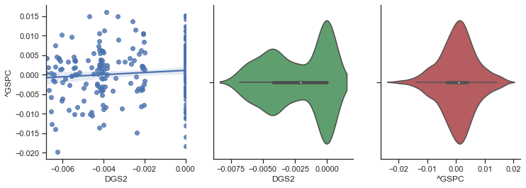

0.1334877775333514

239

0.0

0.00833922507214968

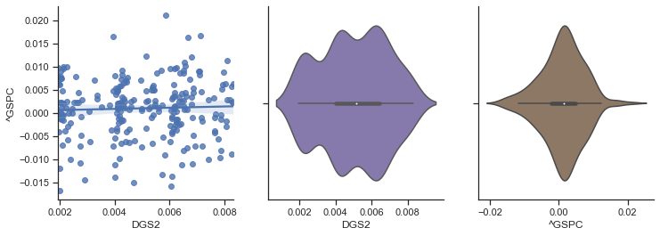

0.24796468706601404

252

0.00833922507214968

0.12727272727272743

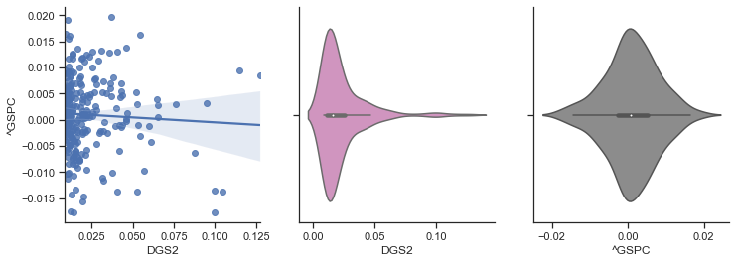

0.24229861844328981

1

['2004-08-03']

['2008-08-01']

252

-0.11864406779661008

-0.008213552361396315

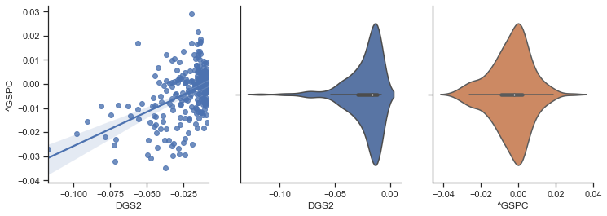

-1.002213014996896

279

-0.008213552361396315

0.0

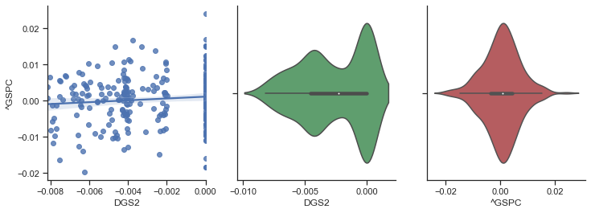

0.12738694163117703

224

0.0

0.007947061803444788

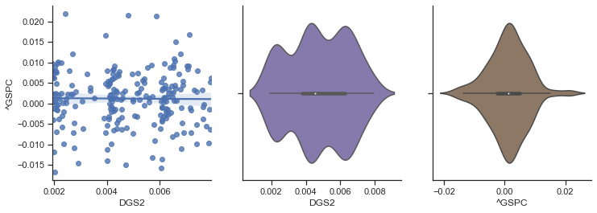

0.25706937237276717

252

0.007947061803444788

0.18367346938775508

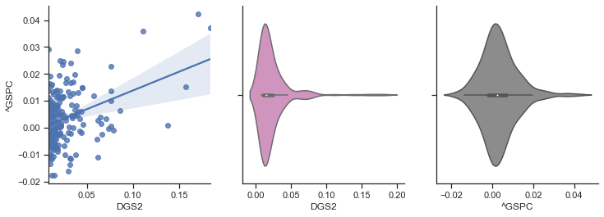

0.7977904690942318

2

['2005-08-02']

['2009-08-03']

251

-0.21904761904761916

-0.01221006695361071

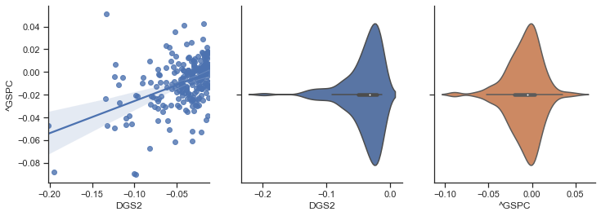

-2.1941947686490035

292

-0.01221006695361071

0.0

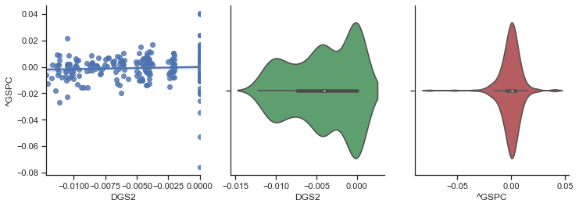

-0.22183521570222198

213

0.0

0.010183299389002087

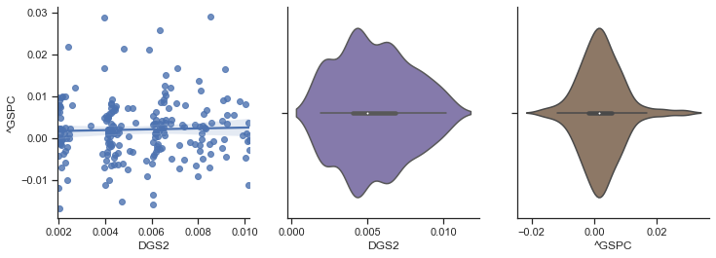

0.44035256472814155

251

0.010183299389002087

0.3750000000000002

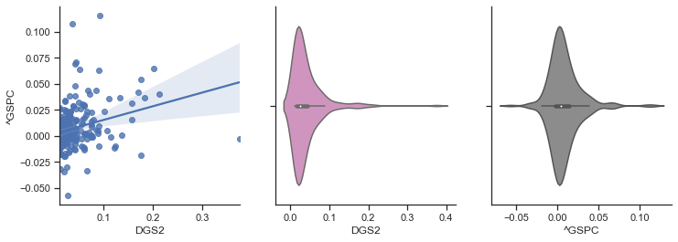

1.8821205622912156

3

['2006-08-02']

['2010-08-03']

251

-0.21904761904761916

-0.021790241243014846

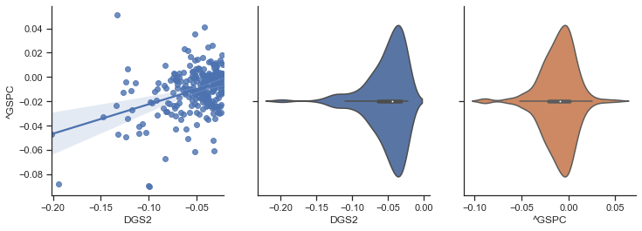

-2.740840792054342

318

-0.021790241243014846

0.0

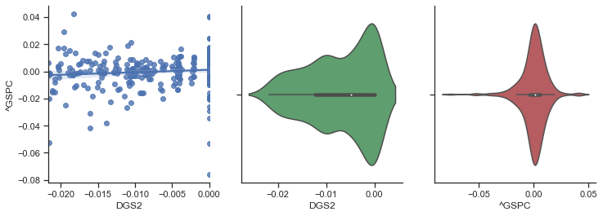

-0.05264143984862879

186

0.0

0.01926178660049621

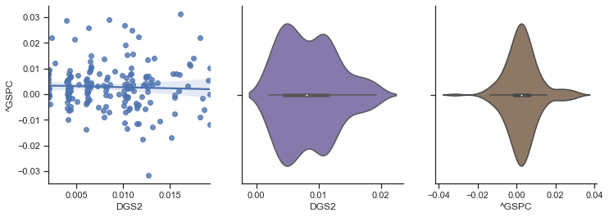

0.5212136974254885

252

0.01926178660049621

0.3750000000000002

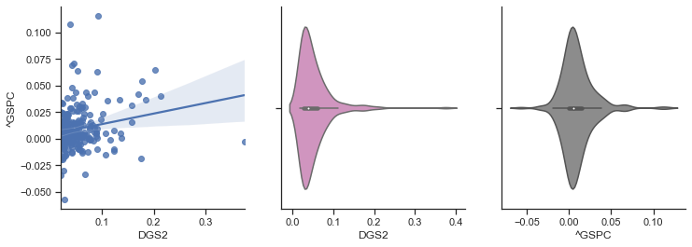

2.273071529488943

4

['2007-08-03']

['2011-08-02']

254

-0.21904761904761916

-0.032786885245901676

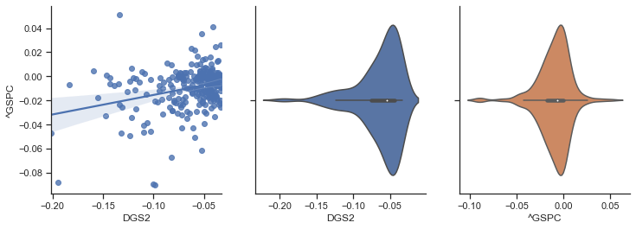

-2.4794303650848675

327

-0.032786885245901676

0.0

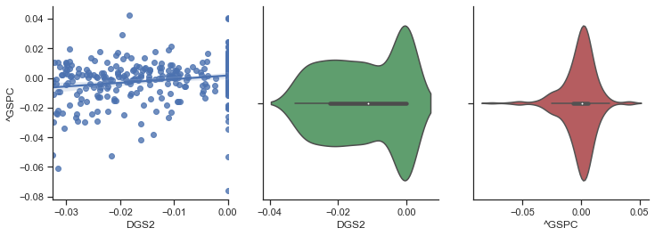

-0.4569722665995001

176

0.0

0.027027027027026973

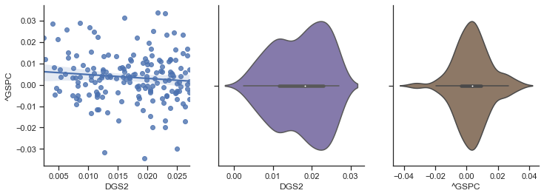

0.6195669518854192

250

0.027027027027026973

0.3750000000000002

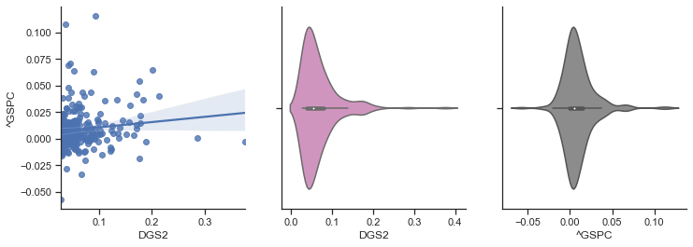

2.2870974379286113

5

['2008-08-04']

['2012-08-01']

251

-0.2962962962962963

-0.03707529843893484

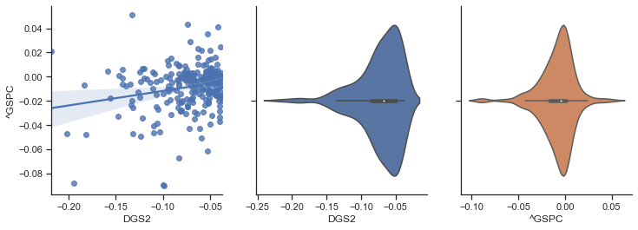

-2.143027703278487

354

-0.03707529843893484

0.0

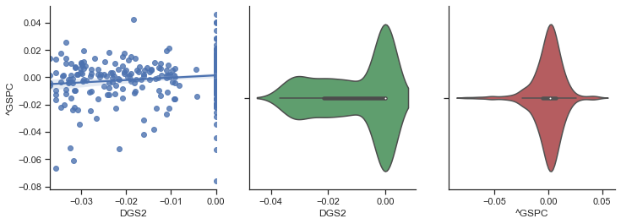

-0.11879509324507365

150

0.0

0.03293311626644946

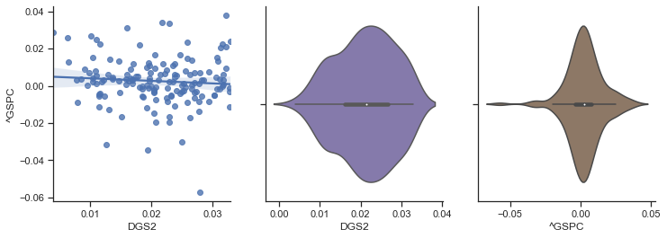

0.37932515238067266

252

0.03293311626644946

0.3750000000000002

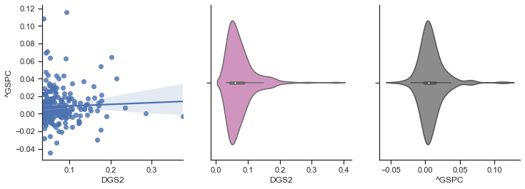

2.079197307903939

6

['2009-08-04']

['2013-08-05']

254

-0.2962962962962963

-0.03703703703703709

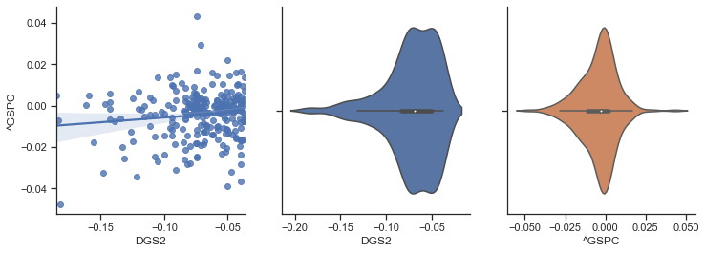

-1.1225784551210891

394

-0.03703703703703709

0.0

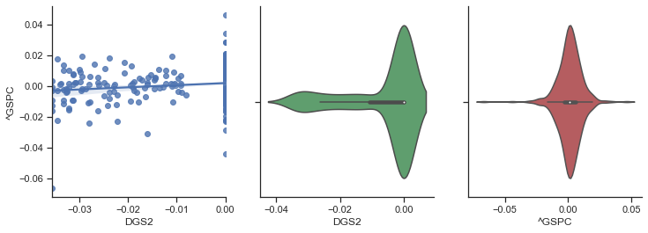

0.3958720328365053

118

0.0

0.034482758620689724

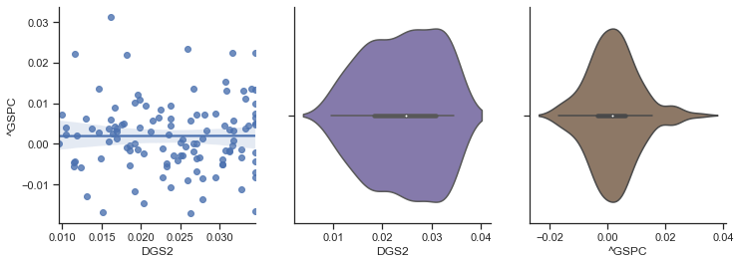

0.2318829252986927

241

0.034482758620689724

0.2857142857142858

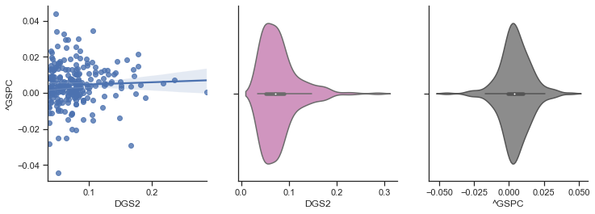

1.0405288850409589

7

['2010-08-04']

['2014-08-05']

253

-0.2962962962962963

-0.0357142857142857

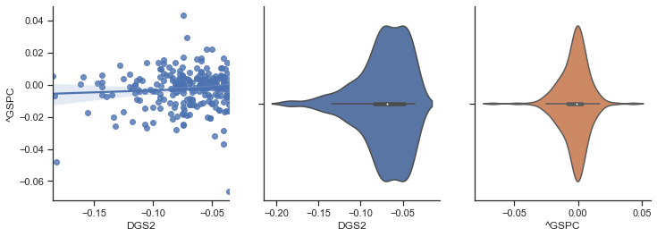

-0.7282661806671821

411

-0.0357142857142857

0.0

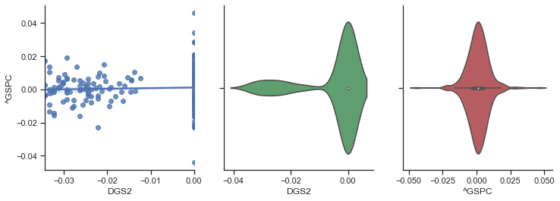

0.403449715998372

94

0.0

0.03703703703703698

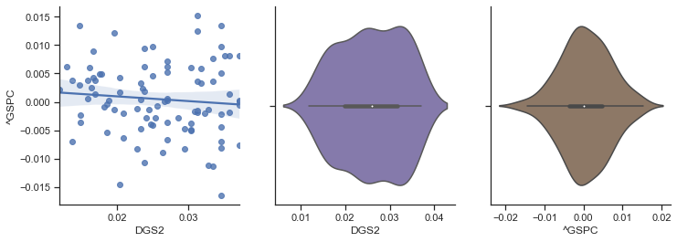

0.04506489393944746

249

0.03703703703703698

0.3055555555555556

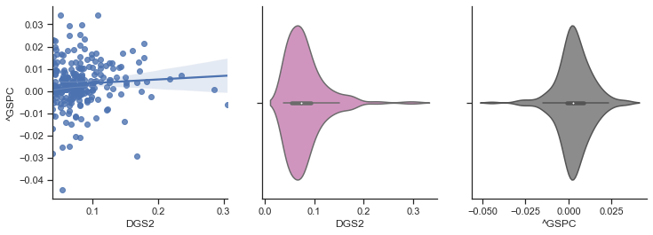

0.8199092070853548

8

['2011-08-03']

['2015-08-05']

253

-0.2962962962962963

-0.033333333333333326

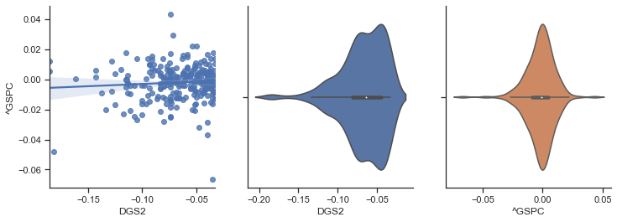

-0.5466145275313135

414

-0.033333333333333326

0.0

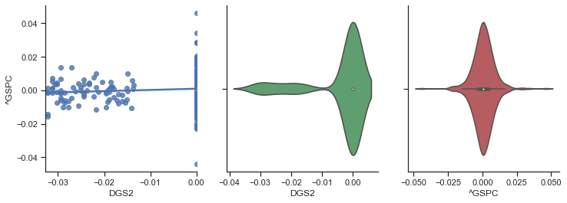

0.2709807598785424

98

0.0

0.03846153846153855

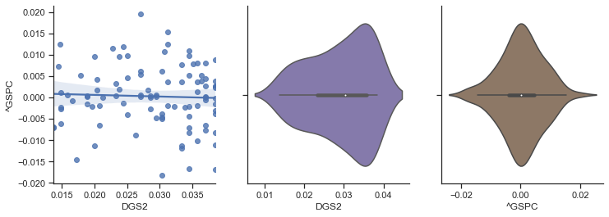

0.024338107345466375

242

0.03846153846153855

0.3055555555555556

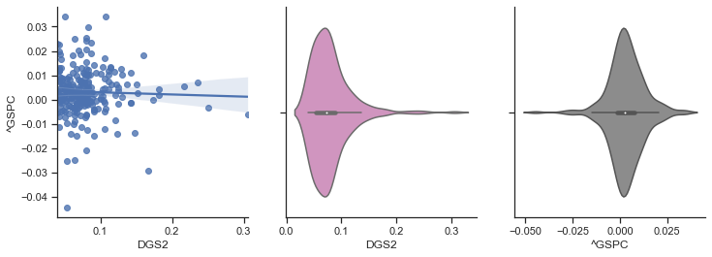

0.7661485453830182

9

['2012-08-02']

['2016-08-04']

255

-0.18571428571428572

-0.030303030303030276

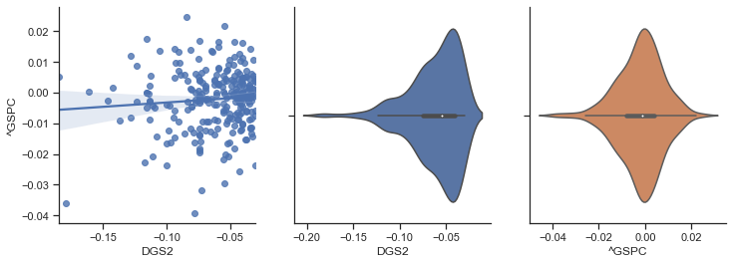

-0.5499073523539041

381

-0.030303030303030276

0.0

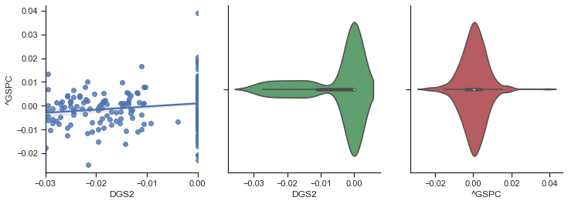

0.10592035488265206

123

0.0

0.034482758620689724

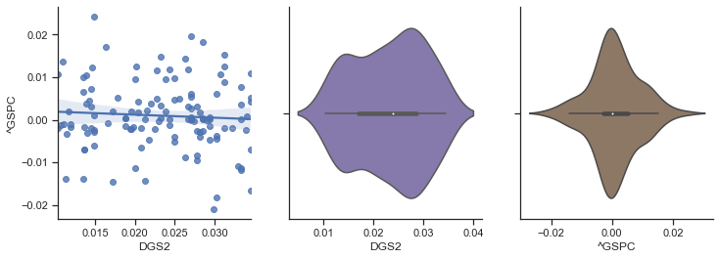

0.12005511160913496

248

0.034482758620689724

0.3055555555555556

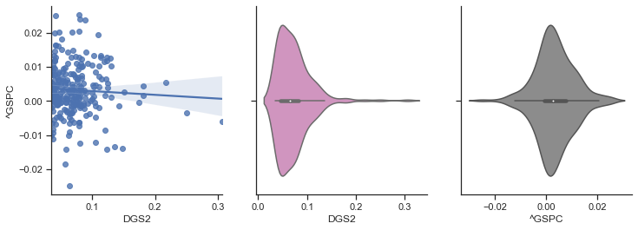

0.7993571080106656

10

['2013-08-06']

['2017-08-04']

254

-0.18571428571428572

-0.024390243902438935

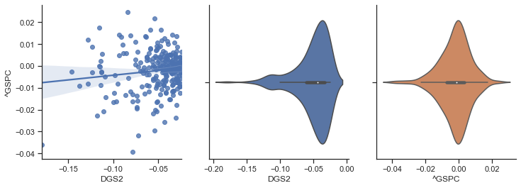

-0.5530135664037501

346

-0.024390243902438935

0.0

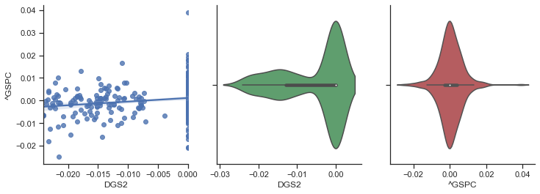

0.07851225717531274

158

0.0

0.0277777777777779

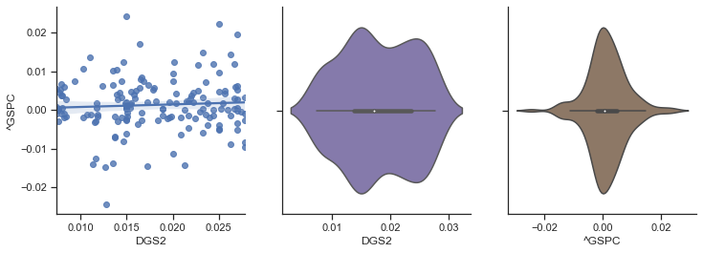

0.20402331048187883

249

0.0277777777777779

0.3055555555555556

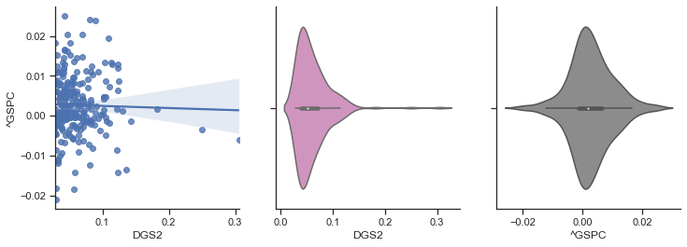

0.6609830307222766

11

['2014-08-06']

['2018-08-06']

254

-0.18571428571428572

-0.014705882352941235

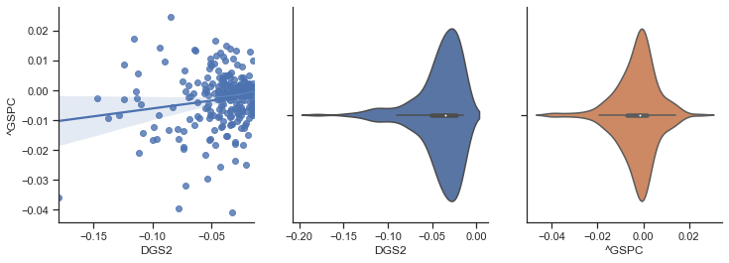

-0.743926149303862

309

-0.014705882352941235

0.0

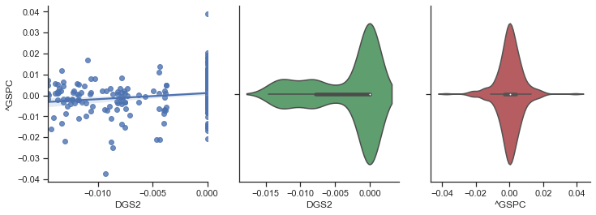

0.02885504693967167

193

0.0

0.019607843137254832

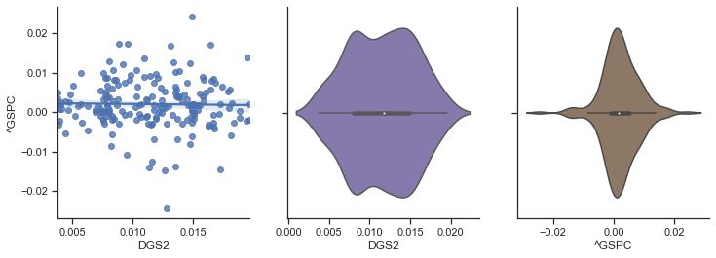

0.3900705495069807

251

0.019607843137254832

0.25

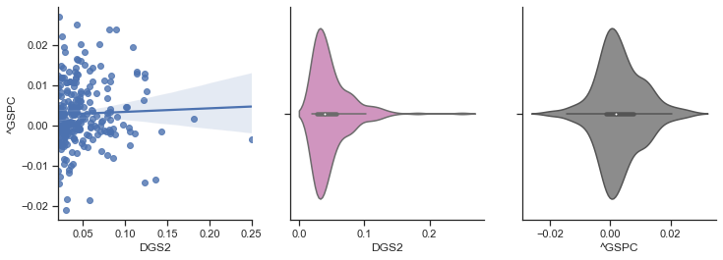

0.7408332896033891

12

['2015-08-06']

['2019-08-07']

252

-0.17948717948717952

-0.011494252873563204

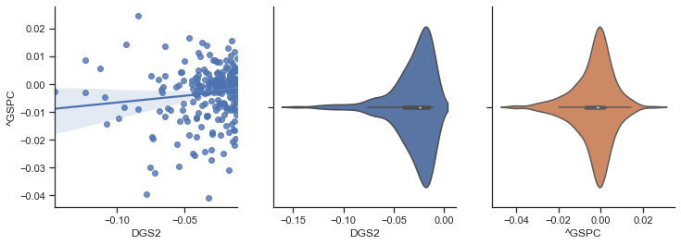

-0.8097097869147311

312

-0.011494252873563204

0.0

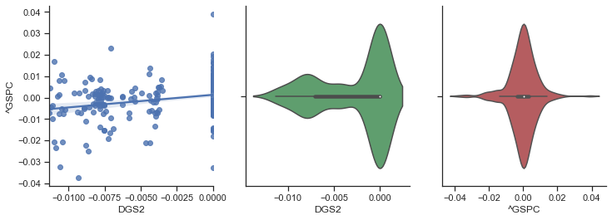

-0.11162515986069177

191

0.0

0.013937793427230005

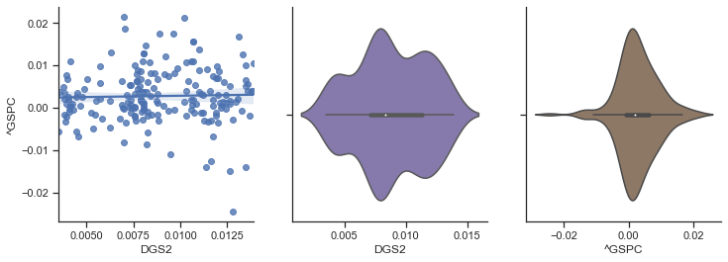

0.5314690627803529

252

0.013937793427230005

0.13559322033898313

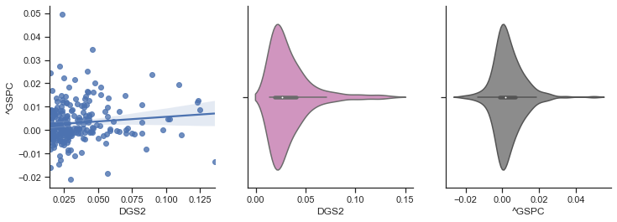

0.7810251478354243

13

['2016-08-05']

['2020-08-06']

251

-0.26530612244897955

-0.012102883675464221

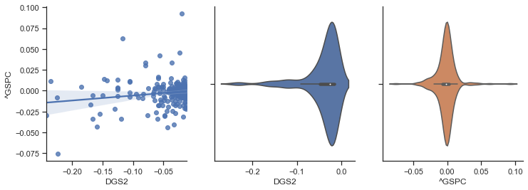

-0.57892342246772

345

-0.012102883675464221

0.0

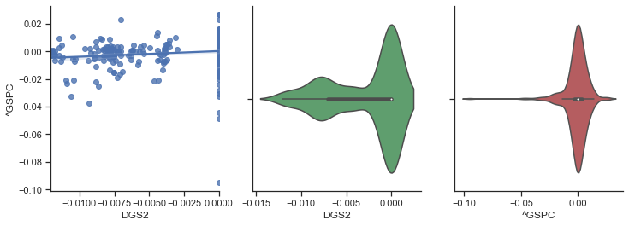

-0.3344310448122675

160

0.0

0.01200000000000001

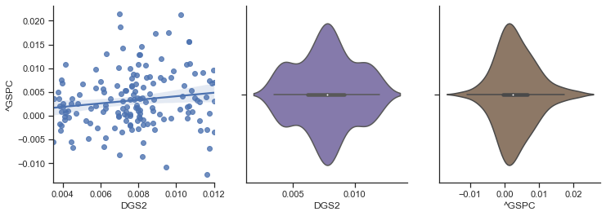

0.5186794217861431

251

0.01200000000000001

0.357142857142857

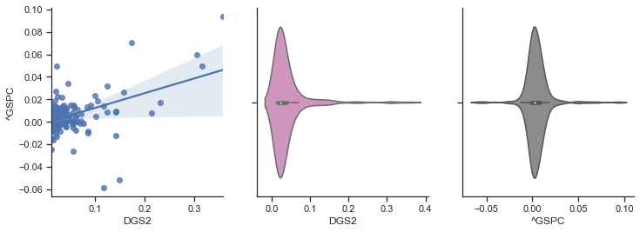

1.0313720798173527